[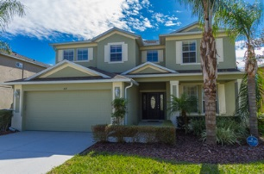](http://floridavilla814.weebly.com/uploads/2/5/6/9/25691417/3996905_orig.jpg)[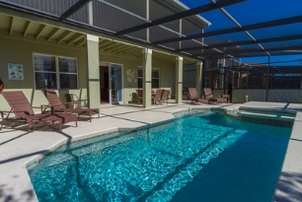](http://floridavilla814.weebly.com/uploads/2/5/6/9/25691417/8889470_orig.jpg)[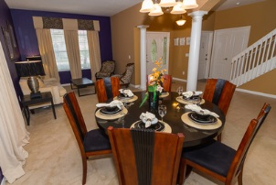](http://floridavilla814.weebly.com/uploads/2/5/6/9/25691417/3393345_orig.jpg)[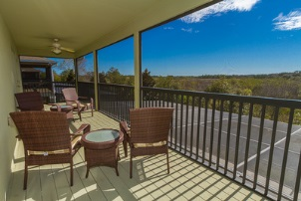](http://floridavilla814.weebly.com/uploads/2/5/6/9/25691417/4499874_orig.jpg)[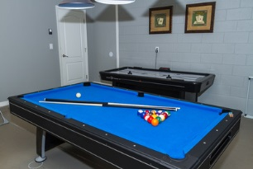](http://floridavilla814.weebly.com/uploads/2/5/6/9/25691417/456844_orig.jpg)[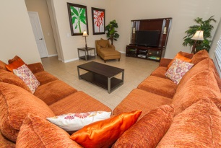](http://floridavilla814.weebly.com/uploads/2/5/6/9/25691417/5370394_orig.jpg)



FLORIDA VILLA 814

www.floridavilla814.weebly.com

5 bedrooms - one King, two queens,

two twin rooms, 4 baths,

Fully air conditioned,

Furnished and equipped to the highest standard

Second floor baloney, giving beautiful views of the nature reserve behind the house. 

Formal dining room, two lounges,

Fitted kitchen with breakfast bar

Games room, fully equipped with pool table and air hockey.

Large swimming pool and Spa

Removable pool security fence

Laundry facilities

Florida Villa 814

Luxury 5 bed/4 bath Villa

[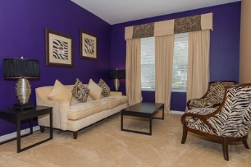](http://floridavilla814.weebly.com/uploads/2/5/6/9/25691417/7921439_orig.jpg)[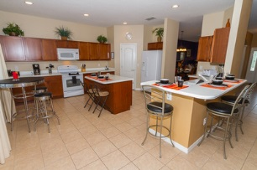](http://floridavilla814.weebly.com/uploads/2/5/6/9/25691417/6379347_orig.jpg)[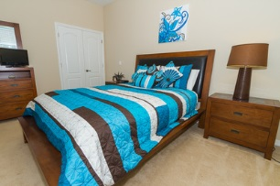](http://floridavilla814.weebly.com/uploads/2/5/6/9/25691417/935087_orig.jpg)[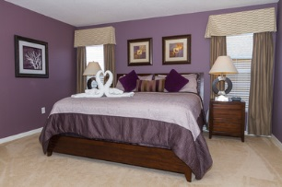](http://floridavilla814.weebly.com/uploads/2/5/6/9/25691417/8923327_orig.jpg)[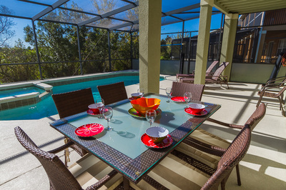](http://floridavilla814.weebly.com/uploads/2/5/6/9/25691417/5037_orig.jpg)[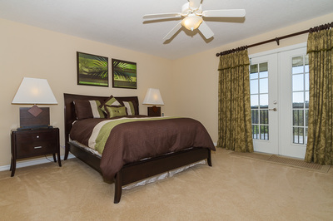](http://floridavilla814.weebly.com/uploads/2/5/6/9/25691417/9768262_orig.jpg)

2 story Villa located in The Shire,

West ﻿Haven, Davenport ﻿area,

Orlando / Disney Area, Florida

South facing so you have the beautiful sunshine all day long

12 minutes from Disney,

20 minutes from Downtown Disney.

2 minutes from Champions Gate Shopping Complex

2 minutes from Publix Supermarket,

Gas Station and Restaurants

5 minutes to I4, 10 minutes Hwy 192

814 Suffolk place  
Davenport  
Florida 33896  
Email: [floridavilla814@yahoo.co.uk](mailto:floridavilla814@yahoo.co.uk)

[www.floridavilla814@weebly.com](http://www.floridavilla814@weebley.com)